REPORT OF MINI PROJECT

NAME:DEEPIKA
BATCH NO:TN-DA-FNBO7
CONTACT NO :+918610805660
EMAIL ID: deepisaravanankumar@gmail.com
PROJECT TITLE: EMPLOYEE ATTRITION
PROJECT DOMAIN: HUMAN RESOURCES
SUMBMISSION DATE:
MENTOR NAME: KUMARAN M
RAW DATASET LINK: https://drive.google.com/file/d/1E79qqDVd76w8T_Juxf4nSy9wM54GfWMe/view?usp=sharing
CLEANED DATASET LINK: https://docs.google.com/spreadsheets/d/14iLlY11UxjbXBOnyhh5PCt_neb9lMRQj/edit?usp=drive_link&ouid=110709859023280711250&rtpof=true&sd=true

EMPLOYEE ATTRITION
INTRODUCTION:
This mini project focuses on analyzing an Employee Attrition dataset using Excel and Power BI. The project demonstrates the complete data analytics workflow, starting from raw data cleaning to creating an interactive analytics dashboard. The goal is to extract meaningful insights that help understand employee distribution, performance, income patterns, and work-related factors.

Purpose of the Project :
The purpose of this project is to:
- Understand employee-related data using business intelligence tools
- Apply data cleaning and transformation techniques in Excel
- Build interactive and meaningful visualizations using Power BI
- Present insights in a professional dashboard and report format

Objectives of the Project :
The key objectives of this project are:
- To clean and preprocess raw employee data using Excel
- To analyze employee demographics such as gender, job role, job level, and company size
- To study income, performance, promotions, overtime, and satisfaction patterns
- To design an interactive Power BI dashboard with filters and charts
- To export and submit the final report in PDF format

Dataset Description
- Dataset Name: Employee Attrition Dataset
- Source: Academic / Practice dataset
- Number of Records: 74k employee
- Key Columns:
  - Employee ID
  - Gender
  - Job Role
  - Job Level
  - Years at Company
  - Monthly Income
  - Performance Rating
  - Work-Life Balance
  - Job Satisfaction
  - Number of Promotions
  - Overtime
  - Company Size

CLEANING SEPTS USING TO DATASET(EXCEL)

Convert given dataset to table
Selecting the rang ctrl+ a and ctrl+ t

Raw dataset

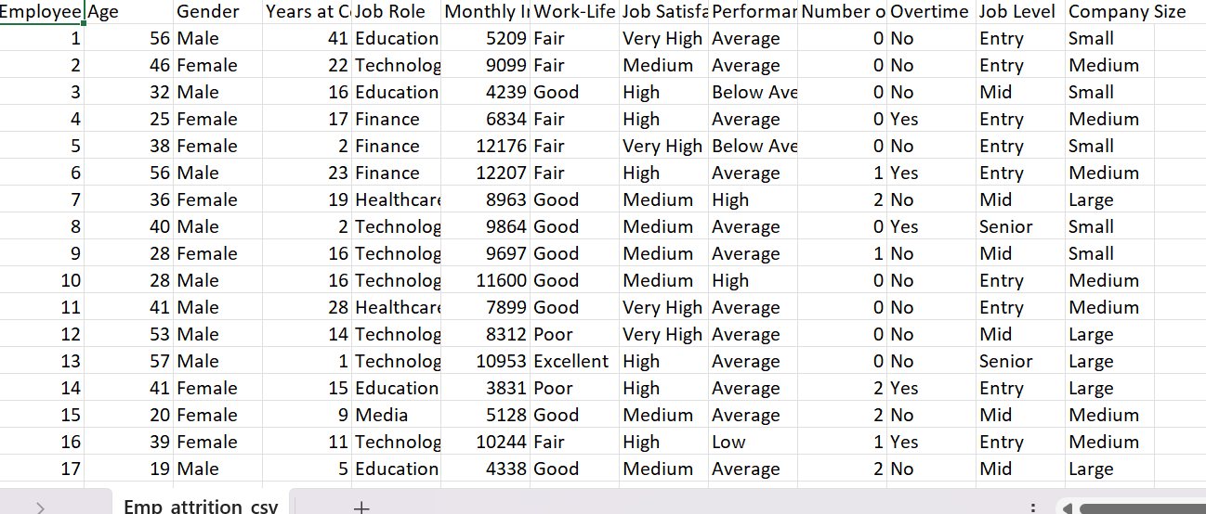

After Create Table:

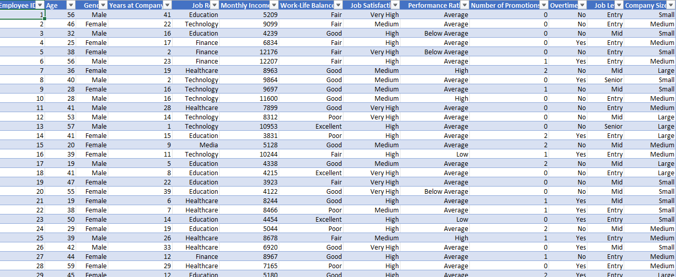

Removed Duplicates:
Data tab ,clicked removed duplicate values select columns ,
112 duplicates values found and removed, 74498 unique values remain.

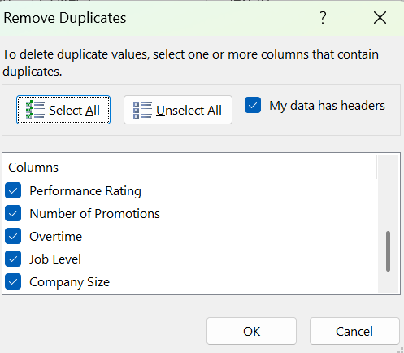

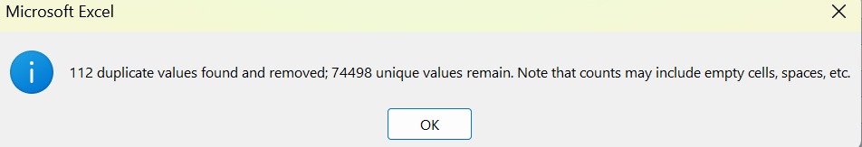

Checked and corrected data :
Select column to number formats and choose correct types.
Make sure column have format ; employee id ,age, income , year of company , number of promotion all of number format and gender, job, rating , satisfaction, performance of text format.

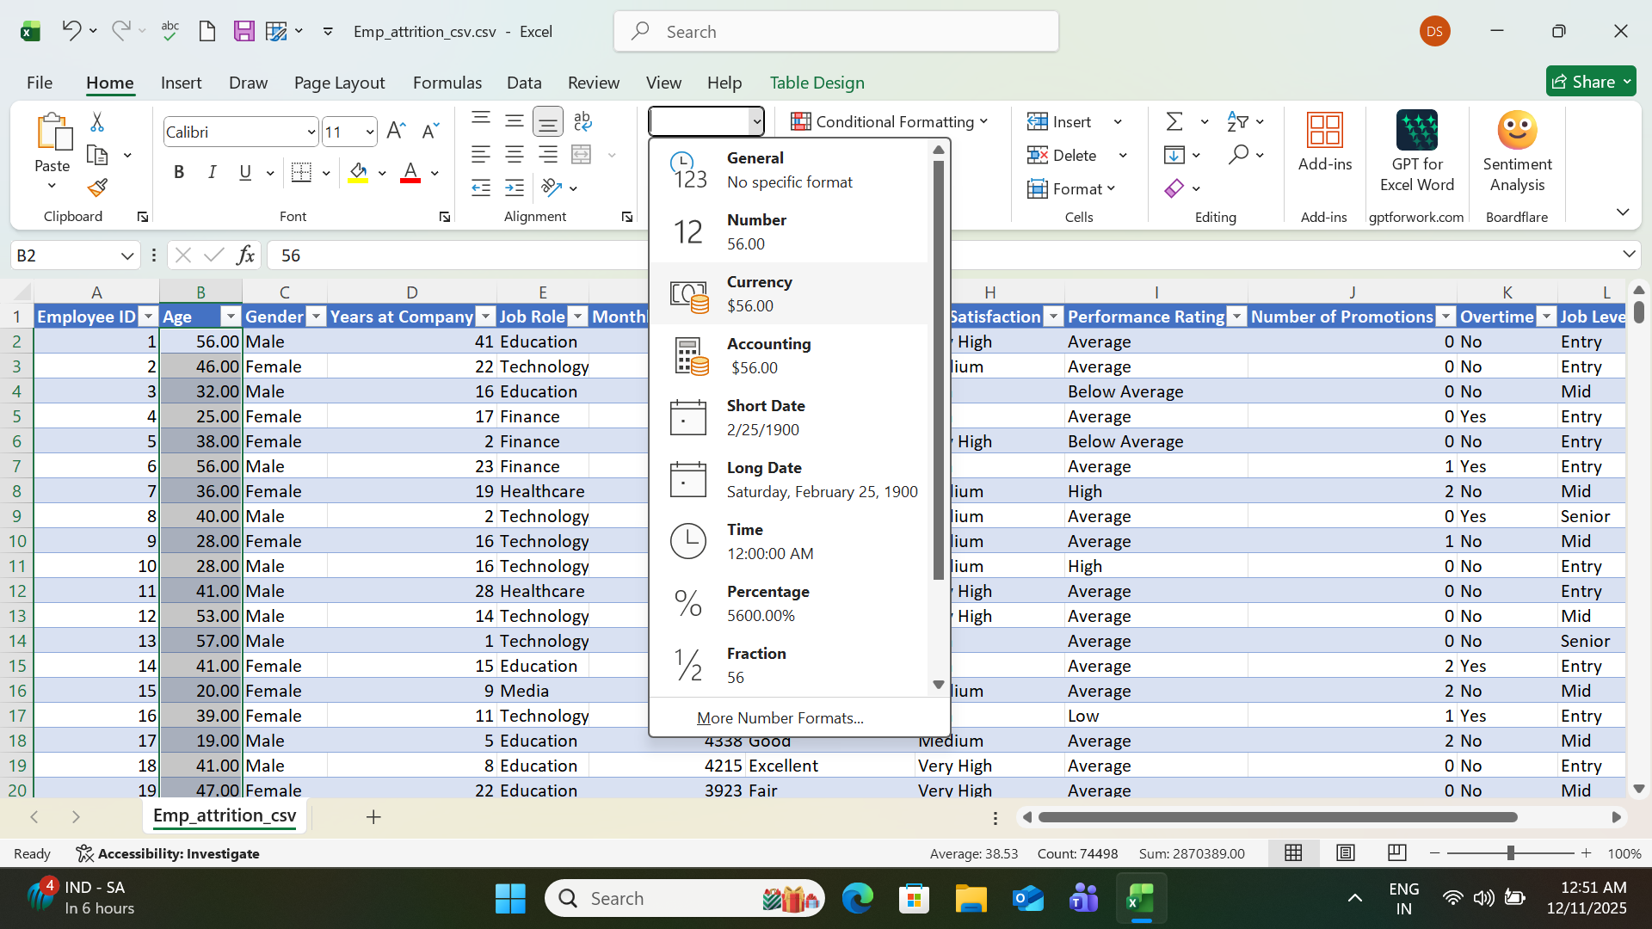

Handled missing values :
Click for issues:
Select all columns Remove missing values, and remove blank rows and correct column names ,correct data types
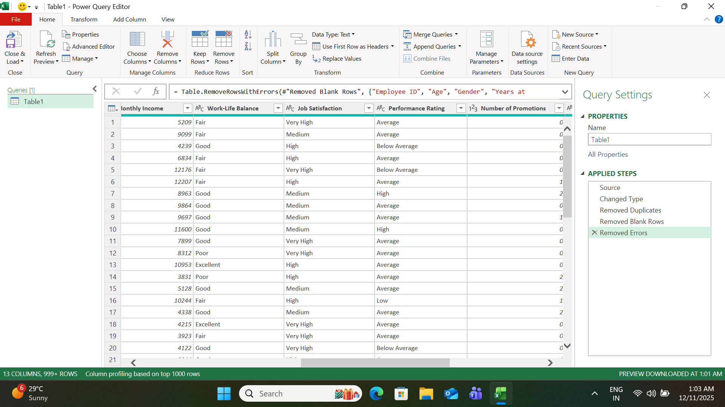

Added conditional columns:
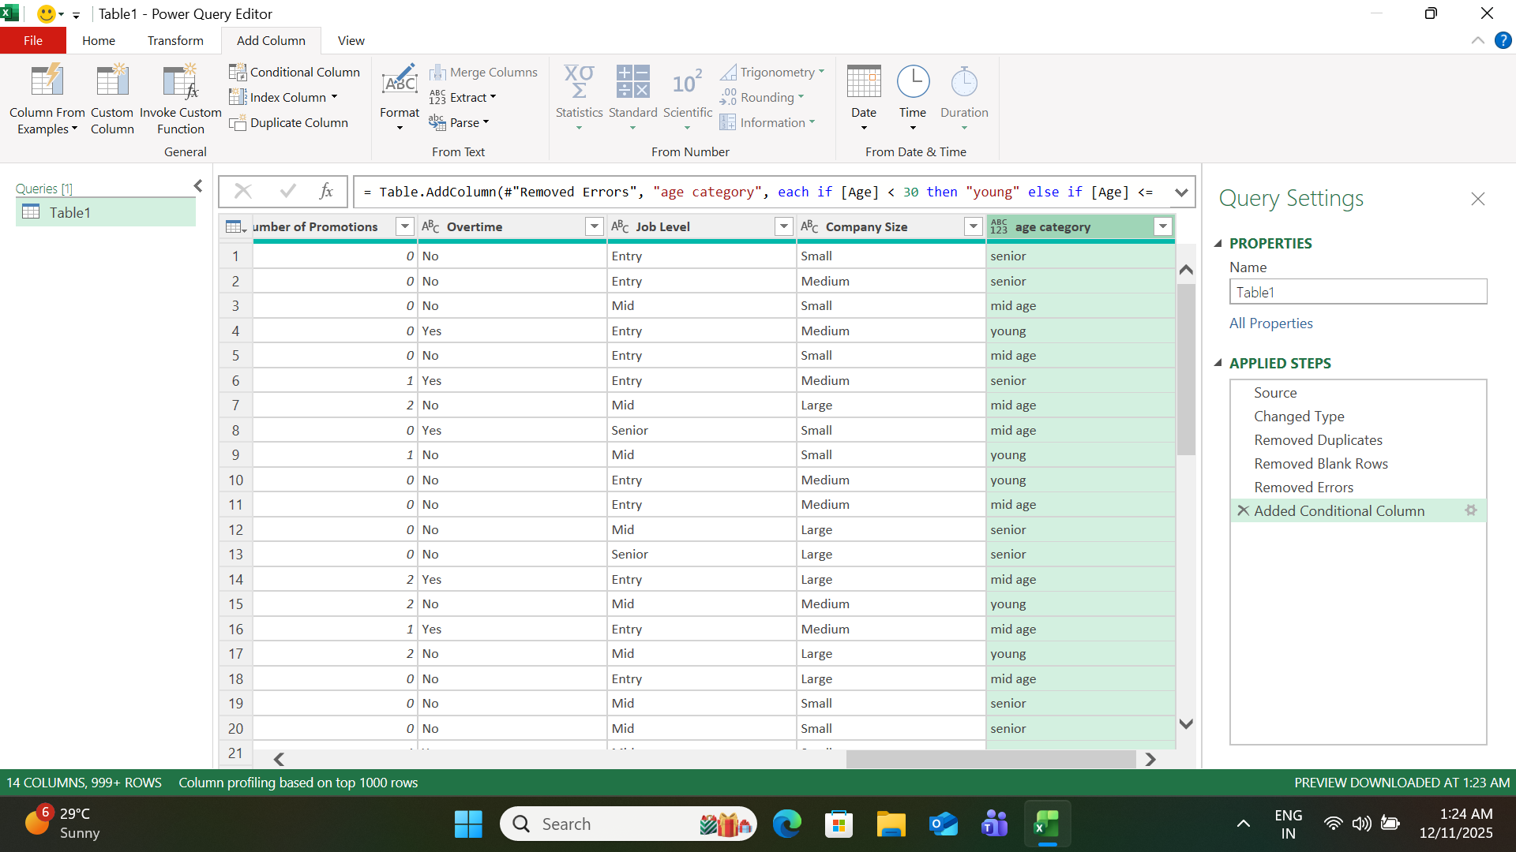

Age category: create age category column using formula
(=if(B2<30, ”young” , if else (b2<=45,”mid age”, else ”senior”)))

Monthly income category: create income category
(=if(f2<6000,”low”, if else(f2<10000,”medium”,else”high”)))

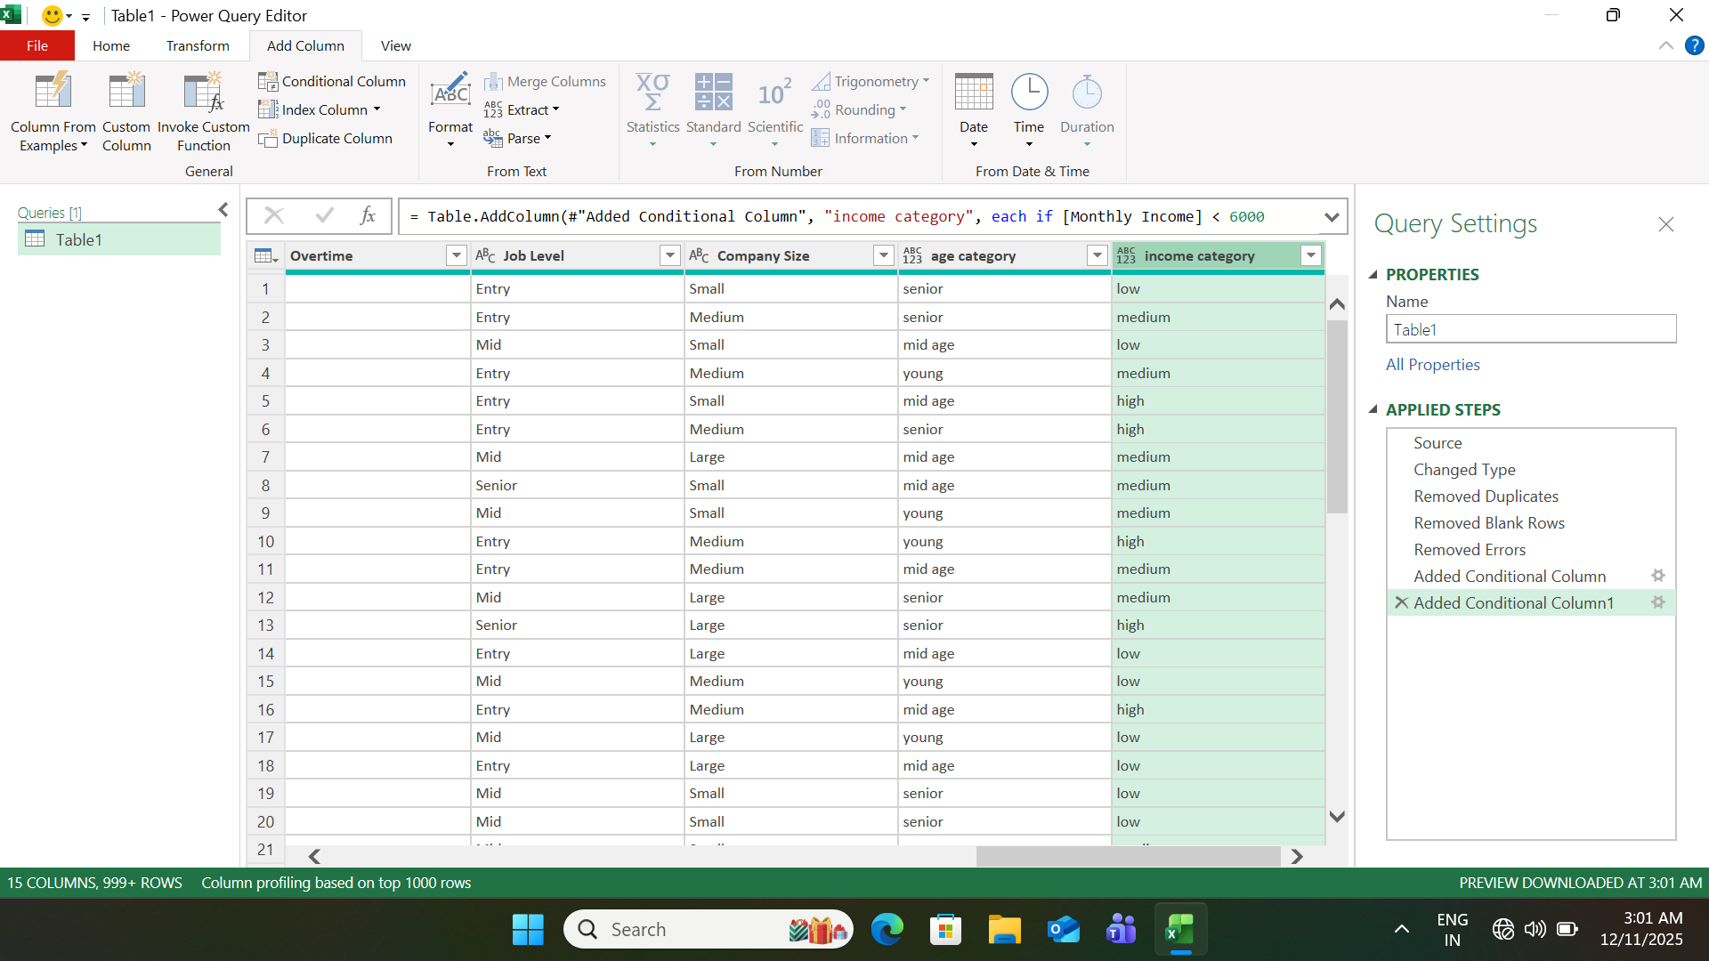

Standardized age column
There is many inconsistent values with no each capital words ,so add new column and used proper function which capitalizes each word
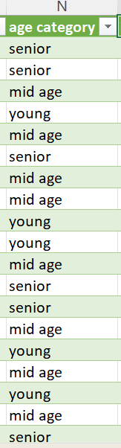
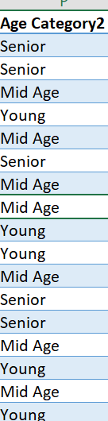

Standardized income column:
There is many inconsistent values with no each capital words ,so add new column and used proper function which capitalizes each word

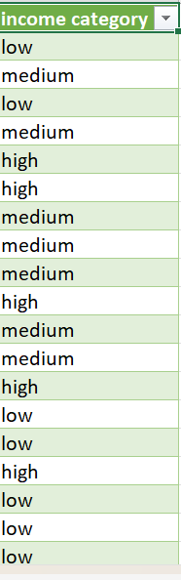
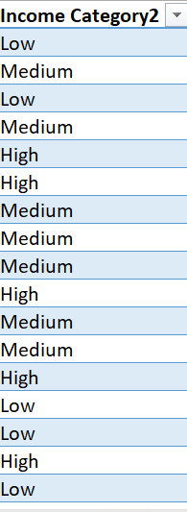

Remove unnecessary columns:

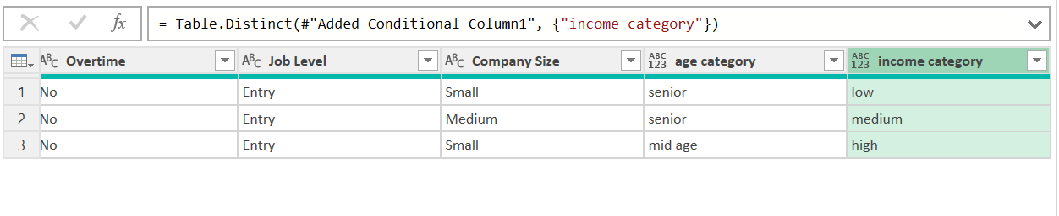
Converted the data set power query into an excel table for easy handling

Create pivot table:
Average income by job role
Rows(job role)
Values(monthly income[average])

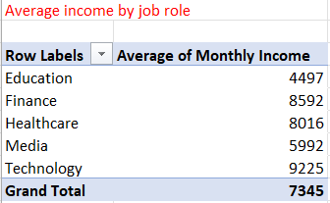
Count of employees by department
Rows(job role)
Values(employee id)

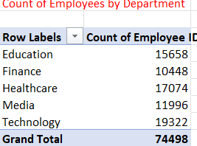

Promotions by gender
Rows(gender)
Values( number of promotions)

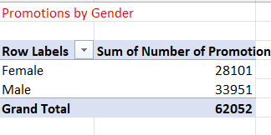
Age category of performance rating
Rows(age category)
Values(performance rating)

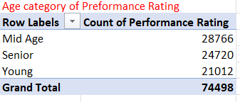

Gender by count of age
Rows(gender)
Values(age[count])

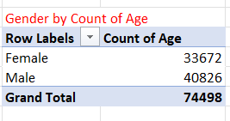

Company size by sum of year at company
Rows(company size)
Values(year at company[sum])

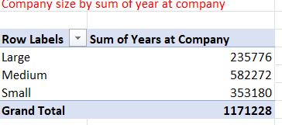

Job satisfaction by year at company
Rows(satisfaction)
Vales(year at company)

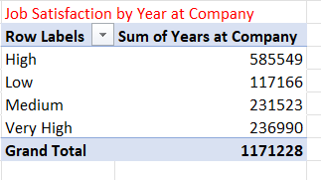
Performance rating by number of promotions
Rows(performance rating)
Values(number of promotions)

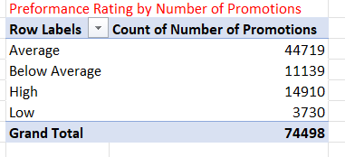

These steps ensured the dataset was accurate for analysis in Power BI.

Problem Identified
During analysis, the following business problems were identified:
- Uneven distribution of employees across job roles
- High overtime among certain job levels
- Income variation across gender and job roles
- Limited promotions for employees in specific company sizes
- Performance ratings not always aligned with income levels
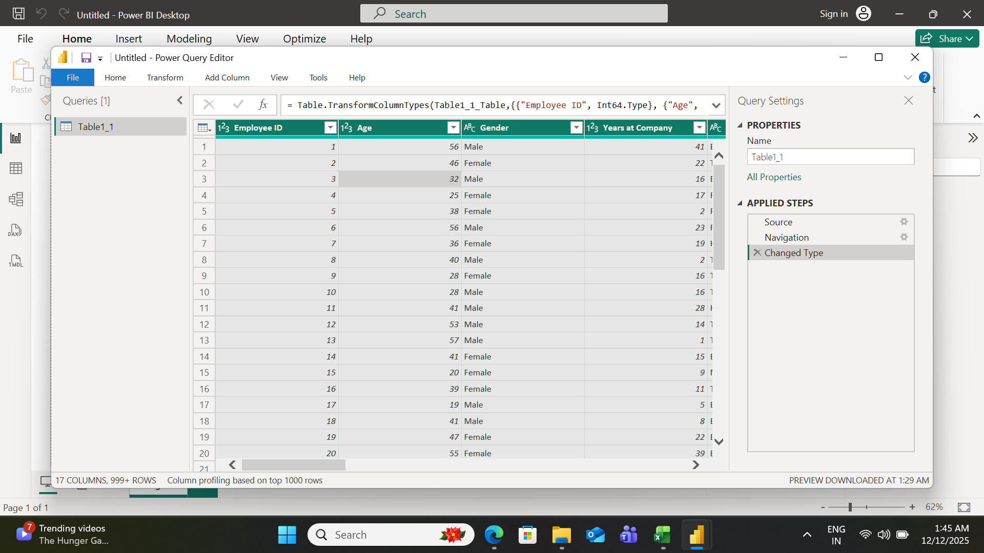

Measures:

Total Employees
Purpose:
To find the total number of employees in the company.
DAX Measure:
Total Employees = COUNTROWS('Table1')
Explanation (for report):
This measure counts the total number of rows in the dataset. Each row represents one employee, so it gives the total employee count.

Average Monthly Income
Purpose:
To understand the average salary of employees.
DAX Measure:
Average Monthly Income = AVERAGE('Table1'[Monthly Income])
Explanation:
This measure calculates the average monthly income of all employees by averaging the values in the Monthly Income column.

Average Years at Company
Purpose:
To analyze employee experience in the company.
DAX Measure:
Average Years at Company = AVERAGE('Table1'[Years at Company])
Explanation:
This measure shows the average number of years employees have worked in the organization.

Total Promotions
Purpose:
To calculate how many promotions were given in total.
DAX Measure:
Total Promotions = SUM('Table1'[Number of Promotions])
Explanation:
This measure adds all promotion counts to show the total number of promotions across the company.

Overtime Employees Count
Purpose:
To identify how many employees work overtime.
DAX Measure:
Overtime Employees =
CALCULATE(
COUNTROWS('Table1'),
'Table1'[Overtime] = "Yes"
)
Explanation:
This measure counts only those employees whose overtime status is marked as “Yes”.

Data Visualization Using Power BI
The following visualizations were created in Power BI:
Card Visuals:
Total Employees, Average Income, Total Promotions, over time count, average year.
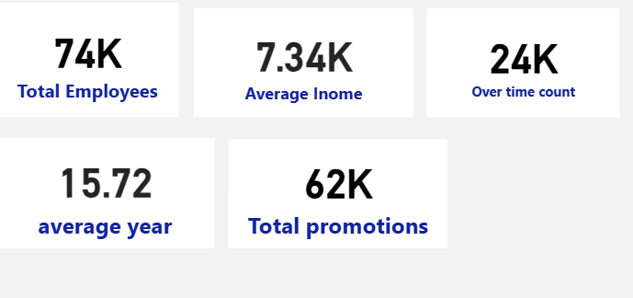

Bar Charts: Employees by Job Role.

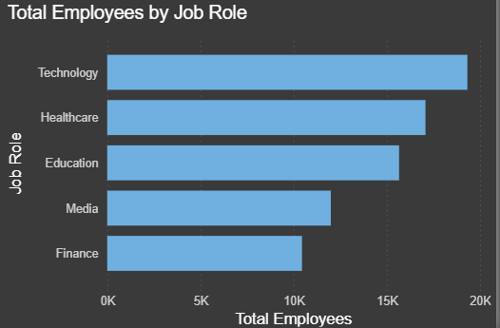
Findings:
- Technology has the highest number of employees.
- Followed by:
  - Healthcare
  - Education
  - Media
  - Finance
- Insight:
  - Technology is the core workforce driver.
  - Attrition in this role would have a high business impact.

Column Charts: sum of Income by Job Level.

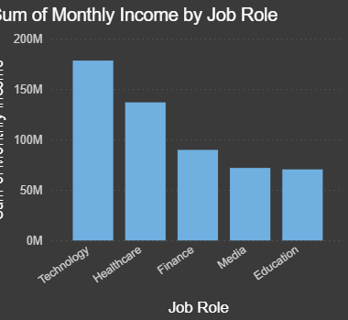

Findings:
Monthly Income by Job Role
Technology roles have the highest total monthly income.
Followed by:
  - Healthcare
  - Finance
  - Media
  - Education (lowest)
- Insight:
  - Pay disparity exists across job roles.
  - Lower-paying roles may have higher attrition rates.

Pie Charts: Gender Distribution, Overtime Distribution

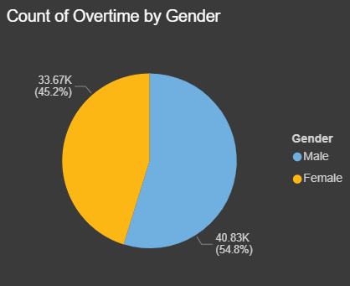

Findings:
Overtime Analysis by Gender
Male employees contribute more to overtime compared to female employees.
- This could indicate:
  - Higher workload on male employees
  - Potential work-life balance issues
Insight: Continuous overtime may increase burnout and attrition risk.

Line Chart: total promotions by performance rating

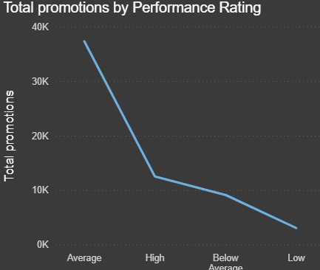
Findings:
Promotions vs Performance Rating
Employees with High performance ratings receive the highest promotions.
Promotions decrease significantly for:
  - Average
  - Below Average
  - Low performers
Insight:
  - Promotion policy is performance-driven.
  - Low performers may feel demotivated, increasing attrition risk.

Funnel chart: total employees by years at company

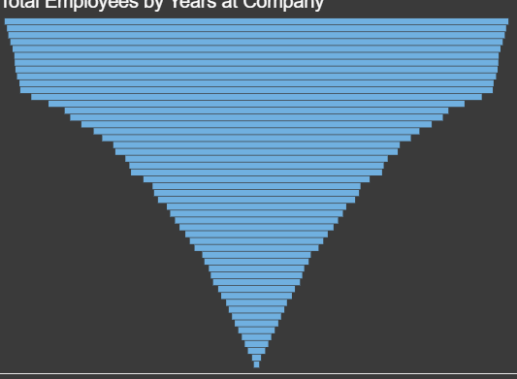

Findings:
Employees by Years at Company
- Most employees fall into mid to long tenure ranges.
- Fewer employees are seen at very low tenure levels.
Insight:
  - The company retains employees well after the initial years.
  - Attrition may be higher during early employment stages.

Donut chart: total employees by job level

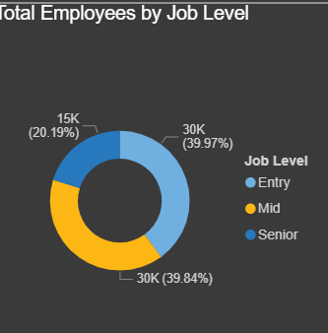

Findings:
Entry-level employees form the largest group.
Mid-level employees are moderate.
Senior-level employees are the smallest group.
Insight:
- Career progression bottlenecks may exist.
- Fewer senior roles could lead to employee exits
Slicers: Gender, Job Role, Job Level, Overtime, Company Size
Each visualization was chosen to clearly communicate insights.

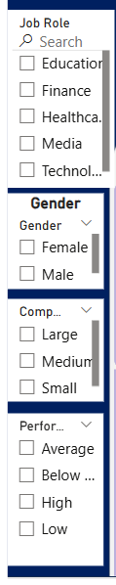
Text box:
Title of dashboard: HR ATTRITION

HR Attrition dashboard(before applying slicer):

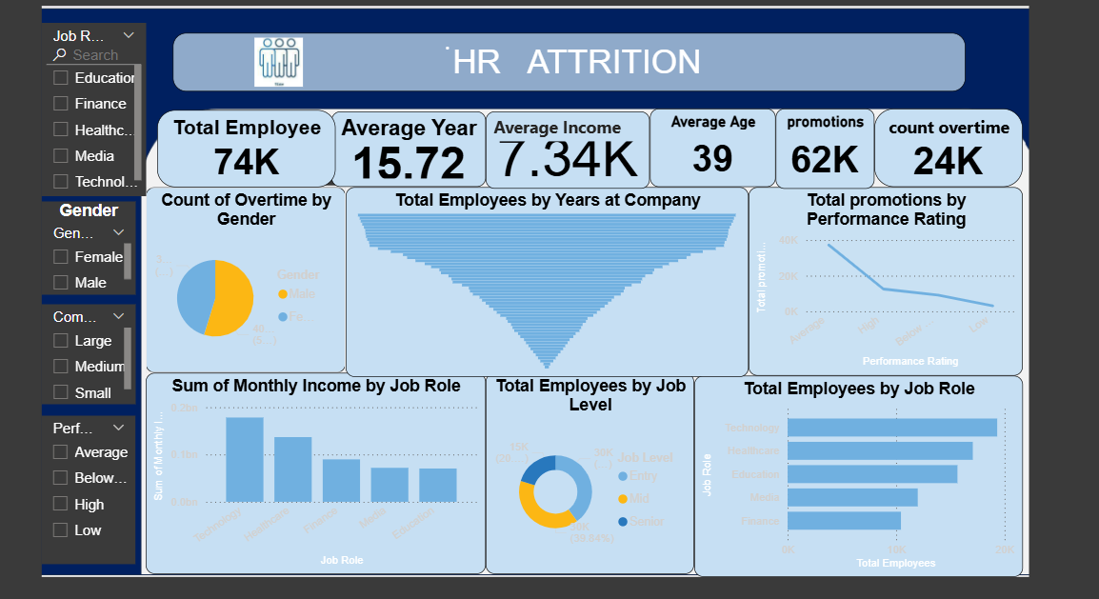

HR Attrition dashboard (after applying slicer):

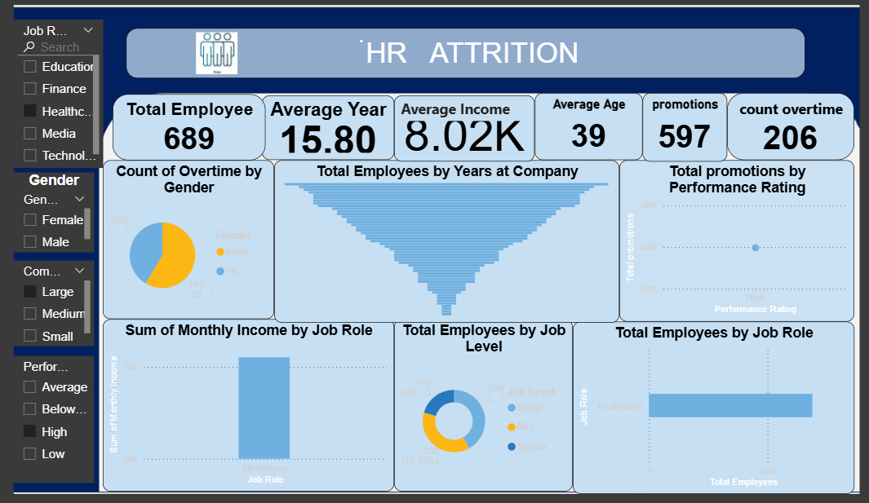

Text Box Insights (Dashboard Explanation)

Text boxes were added in the dashboard to explain insights:
- "Male and female employees are almost equally distributed across the company."
- "Higher job levels generally receive higher monthly income."
- "Employees working overtime show slightly higher performance ratings."
- "Promotion opportunities are limited at entry-level positions."

Analytics Dashboard Design
The Power BI dashboard was designed with:
- KPIs at the top for quick overview
- Filters on the left for interactivity
- Charts placed logically in the center
- Clean layout with proper titles, labels, and legends
The dashboard allows users to analyze employee data dynamically by selecting different filters.

Conclusion:
This mini project successfully demonstrates how Excel and Power BI can be used together for data analysis and visualization. Through proper data cleaning, effective use of DAX measures, and well-designed dashboards, meaningful insights were derived from the employee dataset. The project highlights the importance of data-driven decision-making in human resource analytics and serves as a strong foundation for advanced Power BI projects.

